Strategic Reasoning

Game Theory

Game theory is a framework for analysing interactions between a set of agents

Abstract specification of interactions.

Describes each agent’s preferences in terms of their utility.

Assume agents want to maximise utility

Give us a range of solution strategies with which we can make some predictions about how agents will/should interact.

Payoff Matricies

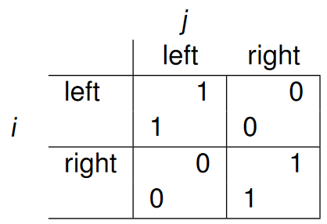

We can characterise the “choose side” scenario in a payoff matrix

Agent I is the row player and gets the lower reward in a cell

Agent j is the column player and gets the upper reward in a cell

Actually there are two matrices here, one (call it A ) that  
specifies the payoff to i and another B that specifies the payoff  
to j.  
‚ Sometimes we’ll write the payoff matrix as (A , B) in  
recognition of this.

Nash Equilibrium

If you know what strategy your opponent will use, you can play the best strategy against it.

**Pareto Optimality**

An outcome is said to be Pareto optimal (or Pareto efficient) if  
there is no other outcome that makes one agent better off  
without making another agent worse off.  
‚ If an outcome is Pareto optimal, then at least one agent will be  
reluctant to move away from it (because this agent will be  
worse off).  
‚ If an outcome ω is not Pareto optimal, then there is another  
outcome ω1 that makes everyone as happy, if not happier,  
than ω.

Can argue as follows:  
‚ “Reasonable” agents would agree to move to ω1 from ω if ω is  
not Pareto optimal and ω1 is.  
‚ Even if a given agent doesn’t directly benefit from ω1, others  
can benefit without it suffering.

